**Consumer Behavior**

<https://www.thinkwithgoogle.com/consumer-insights/consumption-and-spending-habits-during-coronavirus/>

The above link, Google stated how people are in more demand of social interaction.

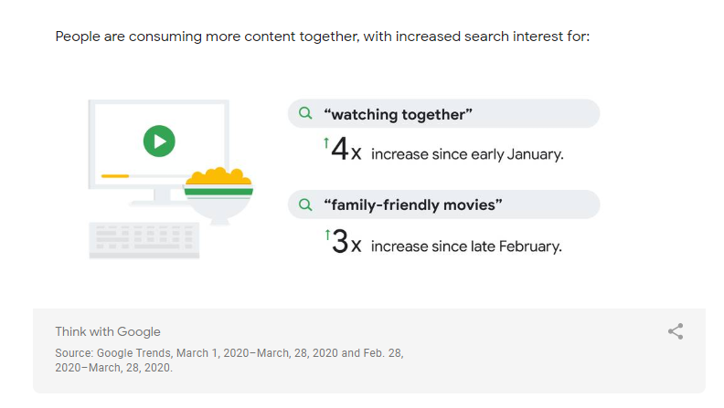

Search interest in “watching together” is up over 4X since January. And search interest in “family-friendly movies” has spiked 3X since late February.

<https://www.mckinsey.com/business-functions/marketing-and-sales/our-insights/survey-us-consumer-sentiment-during-the-coronavirus-crisis>

This is an analysis by McKinsey which conclude that people are trying new shopping behavior during the crisis.

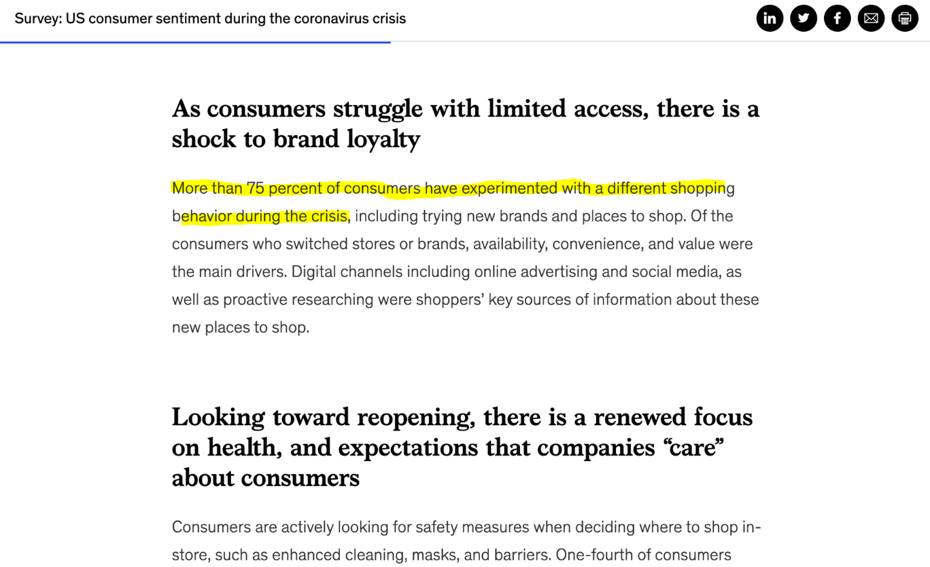

“More than 75 percent of consumers have experimented with a different shopping behavior during the crisis.”

We then apply this data with a different way to dine – Omakase.

<https://observer.com/2020/04/airbnb-launches-virtual-experiences-hosts-zoom-coronavirus-response/>

The above link is analyzing how Airbnb launched online experiences, including virtual penguins and magic classes. Because of this data, we decide that a livestream grill can be a unique addition to Margaret’s restaurant.

